Advanced Data Analysis Study Notes

1 Regression and CV

Linear Models
The linear model is:
- $E\left(y | x\right)=f\left(x^{'}β\right)$, where $x^{'}β=β_{0}+x_{1}β_{1}+..+x_{p}β_{p}$ (this is a generalised linear regression form).
Interactions can be added to capture heterogeneous effects. For example,
- $y=β_{0}+xβ_{2}+dβ_{3}+ϵ$, where $x$ and $d$ are scalars with $d$ being the dummy variable.
Adding the interaction yields the following,
- $y=β_{0}+xβ_{2}+dβ_{3}+xdβ_{4}+ϵ$
This can be rearranged as follows:
- $y=β_{0}+x\left(β_{2}+dβ_{4}\right)+dβ_{3}+ϵ$
The marginal effect of $x$ on $y$ is $β_{2}+dβ_{4}$.
- This marginal effect depends on the dummy (or factor) and hence heterogenous among different groups.

Logistic Regression
The logistic regression model is Bayesian in nature.
- $P\left(y | x\right)=\frac{P(x|y)×P\left(y\right)}{P\left(x\right)}$
Given a dependent variable $y$ that has only two outcomes, this method aims to model the conditional probability explicitly.
- $p\left(y=1\right|x)=\frac{e^{x^{'}β}}{1+e^{x^{'}β}}$
The linear part $x^{'}β$ gives an index value.
- A large positive value pushes the probability towards 1 while a large negative value pulls the probability towards zero.
The model can also be represented as follows:
- $\log\left[\frac{p}{1-p}\right]=x^{'}β$, where $p=p\left(y=1 | x\right)$
or
- $\log\left[\frac{p(y=1|x)}{p(y=0|x)}\right]=x^{'}β$
The LHS is the log odds ratio.
- The interpretation for any $β_{k}$ comes as the marginal effect on the log odds ratio.
The logistic regression has a utility interpretation.

1.3 Out-of-Sample Predictions (OOS)
OOS is the performance of your model on new data.

1.4 Deviance and Uncertainty
The sample mean is as follows:
- $\overline{x}=\frac{1}{n}\sum_{i=1}^{n}{x_{i}}$
The variance of this statistic can be calculated as:
- $var\left(\overline{x}\right)=var\left(\frac{1}{n}\sum_{i=1}^{n}{x_{i}}\right)=\frac{1}{n^{2}}\sum_{i=1}^{n}{var\left(x_{i}\right)}=\frac{σ^{2}}{n}$ where $σ^{2}=E\left[{\left(x_{i}-,u \right)}^{2}\right]$

1.7 Heteroskedasticity
Suppose $y=x^{'}β+ϵ$,
- Homoskedasticity, $var\left(ϵ | x\right)=σ^{2}$, give credits equally to all observations.
- Heteroskedasticity, $var\left(ϵ | x\right)=g\left(x\right)$, assumes different observation have different credibility.

1.8 Bootstrapping
Bootstrap methods mimic the GDP and sampling distribution by using the existing data.
- This computational algorithm is used to construct sampling distributions. Instead of relying on theoretical approximation, the bootstrap uses resampling from the current sample to mimic the sampling distribution.
- The sampling distribution is simply the distribution on an estimator (e.g., $\hat{β}$) that we get by re-estimating $β$ on each of multiple datasets of size $n$ from the population.
Figure 1.1: Bootstrapping $β$
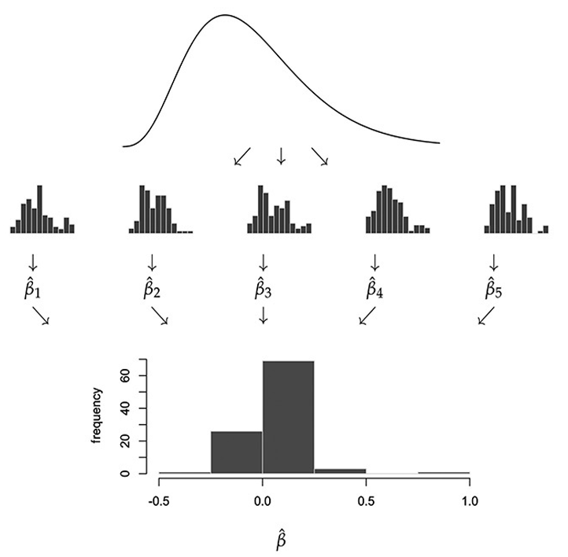
The algorithm for the nonparametric bootstrap is as follows:
- Given data ${\left\{z_{i}\right\}}_{i=1}^{n}$ for $b=1,…B$:
- Resample with-replacement $n$ observations ${\left\{z_{i}^{b}\right\}}_{i=1}^{n}$,
- Calculate your estimate, say, ${\hat{β}}_{b}$, using this resampled set.
- Then ${\left\{{\hat{β}}_{b}\right\}}_{b=1}^{B}$ is an approximation to the sampling distribution for $\hat{β}$.
The standard deviation of this bootstrap sample can be approximated:
- $se\left(\hat{β}\right)≈sd\left({\hat{β}}_{b}\right)=\sqrt{\frac{1}{B}\sum_{b}{{\left({\hat{β}}_{b}-\hat{β}\right)}^{2}}}$
Then, you can build the 95% confidence interval (as long as the estimator is unbiased):
- $β∈\hat{β}±2sd\left({\hat{β}}_{b}\right)$

1.9 Cross Validation
The $k$-fold out-of-sample (OOS) validation algorithm is as follows: given a dataset of $n$ observations, ${\left\{\left[x_{i}, y_{i}\right]\right\}}_{i=1}^{n}$:
- Split the data into $K$ evenly sized random subsets (folds):
- For $k=1…K$:
- Fit the coefficients $\hat{β}$ using all but the $k$th fold of data,
- Record $R^{2}$ on the left-out $k$th fold (or MSE).
Then, you can estimate the sample of $k$ OOS $R^{2}$ or MSE values (and you can average out the MSE values as well).

1.10 Benjamini-Hochberg
The false discovery (FD) proportion is:
- $FD Proportion=\frac{\# false positives}{\# tests called significant}$
The false discovery rate (FDR) is:
- $FDR=E\left[FDP\right]=E\left[\frac{\# false positives}{\# tests called significant}\right]$
The Benjamini-Hochberg (BH) FDR Control algorithm is as follows: for $N$ tests, with $p$-values $\left\{p_{1}… p_{N}\right\}$ and target $FDR q$:
- Order your $p$-values from smallest to largest as $p_{(1)}…p_{\left(N\right)}$,
- Set the $p$-value cutoff as $p^{*}=\max\left\{p_{\left(k\right)}:p_{\left(k\right)}≤q\frac{k}{N}\right\}$.
The rejection region is the set of all $p$-values $≤p^{*}$, and this ensures that $FDR≤q$.

1.11 $k$-fold OOS Validation
$k$-folds OOS validation makes the estimation trustworthy and avoids over parameterisation (parameter saturation) and favours parsimony.

Forward Stepwise
- The backward stepwise approach starts from the full model and removes useless variable.
- It suffers from multicollinearity and large dimension $p$ (not so good).
- The forward stepwise regression starts from univariate models and adds useful regressors one at a time.
- This is an example of greedy search strategy.

2 Least Absolute Shrinkage and Selection Operator (LASSO)

2.1 LASSO
The simple MLE estimation looks like:
- $\hat{β}=\arg{\min\left\{-\frac{2}{n}\log{lhd\left(β\right)}\right\}}$
where $lhd\left(β\right)$ is the likelihood function.
- $β$ is so free that it can be wild, it is important for such freedom to be regularised, especially when the parameter space is large.
- The principle is “I would rather have nothing than too much noise”.
The penalised deviance is:
- $\hat{β}=\arg{\min\left\{-\frac{2}{n}\log{lhd\left(β\right)}\right\}}+λ\sum_{k}{c\left(β_{k}\right)}$
It is LASSO (L1 regularisation) when the cost function $c\left(β_{k}\right)=\left|β_{k}\right|$ or simply:
- $\hat{β}=\arg{\min\left\{-\frac{2}{n}\log{lhd\left(β\right)}\right\}}+λ\sum_{k}{\left|β_{k}\right|}$
To illustrate:
- Deviance of a linear model is quadratic. Suppose ${\left(β-b\right)}^{2}$ for simplicity (over-simplified), where $b≠0$ is the MLE estimate.
- The penalty term is $\left|β\right|$ by letting $λ=1$ for simplicity.
The objective function is then:
- $f={\left(β-b\right)}^{2}+\left|β\right|$
Hence,
- If the signal $\left|b\right|$ (MLE estimate) is small, then the penalty term dominates. Because if choosing $\hat{β}=b$, the loss is $\left|b\right|$; while the loss is a much smaller $b^{2}$ if setting $β=0$. In this case we should let $\hat{β}=0$.
- Otherwise, the likelihood part dominates. Suppose if $\left|b\right|>1$, we should let $\hat{β}$ to be closer to $b$ instead of $0$.
- The objective of LASSO is feature selection, to select the features which are most relevant (strong signal) as it shrinks model’s weights to zero.

Figure 2.1: Deviance and Penalty
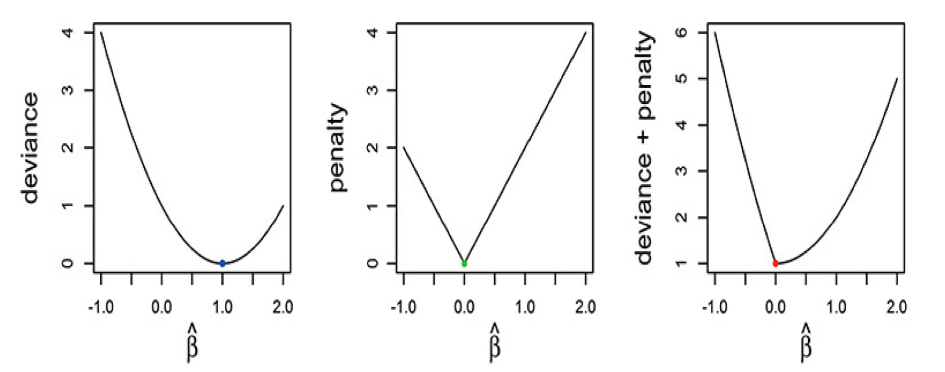
Figure 2.2: LASSO vs OLS Regression Coefficients
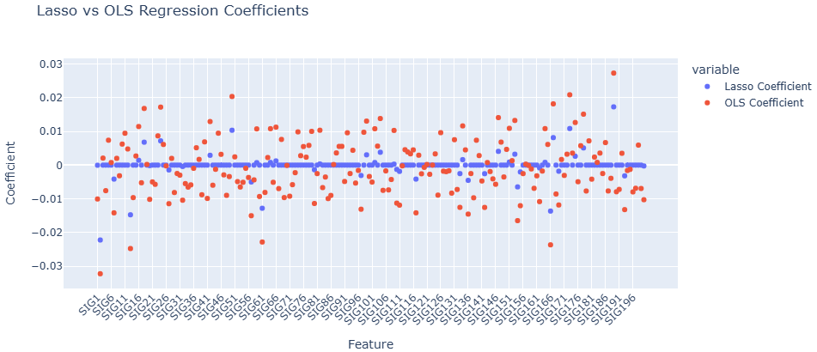

2.2 Ridge
Ridge (L2 regularisation) is as follows:
- $\hat{β}=\arg{\min\left\{-\frac{2}{n}\log{lhd\left(β\right)}\right\}}+λ\sum_{k}{β^{2}}$
or
- $f={\left(β-b\right)}^{2}+β^{2}$ (the objective function)
Ridge addresses the problem of multicollinearity among predictor variables by shrinking the model’s weight towards zero.

2.3 Elastic Net
The Elastic Net (L1 and L2 regularisation) penalises close and far parameters.
- It combines Ridge and LASSO.

2.4 Model Selection
A summary of how to choose $λ$ is as follows:
- $AIC=deviance+2df$
- ${AIC}_{c}=deviance+2df\frac{n}{n-df-1}$
- $BIC=deviance+\log\left(n\right)×df$
Estimate the model once and choose the value $λ$ that gives the optimal criterion (AICc is recommended).
- These are all in-sample, so they are fast to compute.
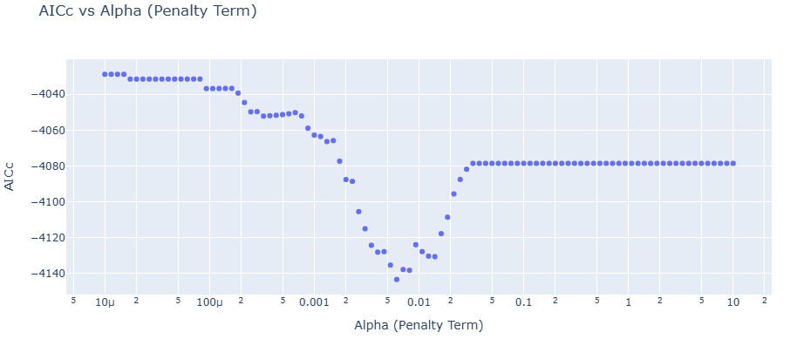
Figure 2.3: AICc vs Alpha (Penalty Term)
Figure 2.4: AICc vs C (Inverse Penalty Term)
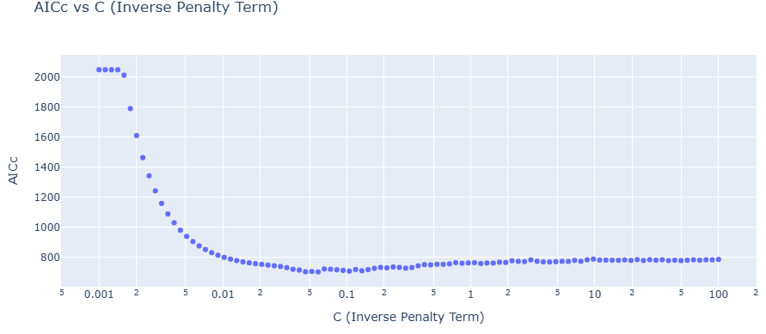

2.5 Cross Validation
Figure 2.5: LASSO Cross-Validation Results
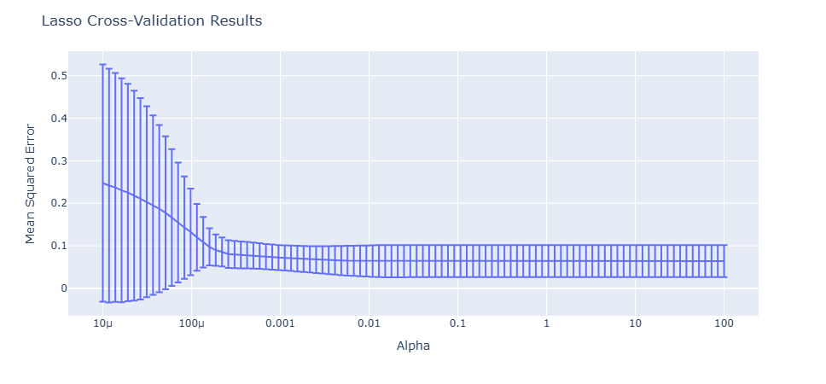
Figure 2.6: AICc and $k$
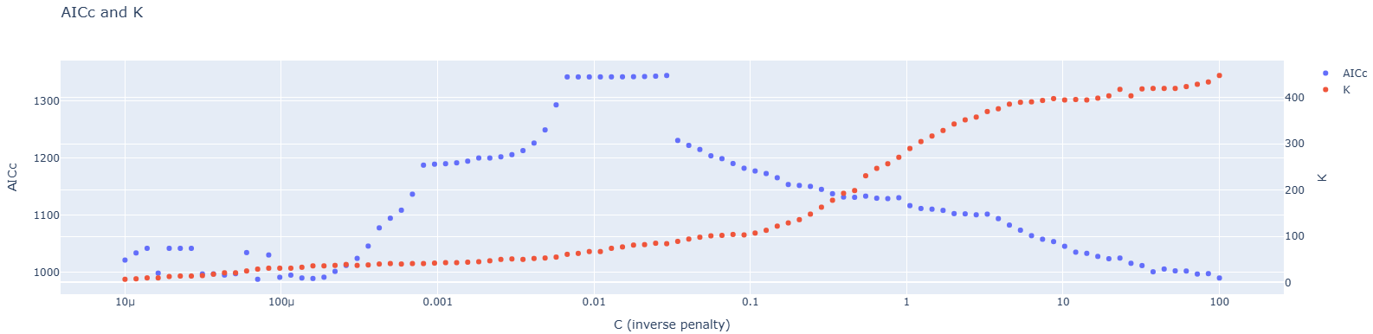

3 Classification

3.1 Multinomial Logistic Regression
Generalised linear models are a class of regression models (e.g., probit, logit and multinomial) that can be used to model a wide range of relationships between a response variable and one or more predictor variables which allow for flexible, non-linear relationships by using a different underlying statistical distribution.
- Probit & Logit $⇒$ binary outcome,
- Multinomial $⇒ ≥2$ outcomes.
A multinomial distribution has multiple possible outcomes, denoted by $K$.
- Consider these $K$ possible outcomes competing in a race,
- The one with the highest potential has a higher chance to win (not always win).
Suppose we have a $K×1$ vector $y_{i}$ for individual $i$. This vector has only one element taking value $1$ (outcome) and the others $0$.
- For example, if $K=3$ and individual $i$ chose $2$, then $y_{i}=\left(0, 1, 0\right)$, or $y_{i1}=y_{i3}=0$ and $y_{i2}=1$. Hence, only and only one element can take value $1$.
Use $y$ as a general individual (no subscript $i$):
- $p\left(y_{j}=1 | x\right)=\frac{e^{x^{'}β_{j}}}{\sum_{k=1}^{K}{e^{x^{'}β_{k}}}}$
If you add any constant to all $β_{k}$ by the same amount, the probability does not change.
- Thus, we usually set $β_{1}=0$ as a reference (default) group.
Define $B$ as the collection of all $β_{k}$’s. The penalised deviance minimisation is as follows:
- $\min\left\{-\frac{2}{n}\sum_{i=1}^{n}{y_{ik}}\log{p_{ik}\left(x_{i}^{'}B\right)}+λ\sum_{k}{\sum_{j}{\left|β_{kj}\right|}}\right\}$
This interpreted as the log-odds ratio:
- $\log\left(\frac{p_{a}}{p_{b}}\right)=\log\left(\frac{e^{x^{'}β_{a}}}{e^{x^{'}β_{b}}}\right)=x^{'}\left(β_{a}-β_{b}\right)$
The interpretation is odds of an event occurring relative to it not occurring (or to some baseline group).

3.2 Support Vector Machine
The supper vector machine wants to use line (plane, hyperplane) to separate two categories (multiple is possible, but can be inferred based on two categories).
- We want such boundary to be far from the marginal points, which are called support vectors.
Even though a hyper-plane looks like $xβ+β_{0}$, you are able to make many $x$’s such as a general polynomial. Hence, a seemingly linear hyper-plane can be nonlinear.
- A highly flexible method is to construct these $x$ values as kernels, where the idea is that a variable $x$ is more affected by its neighbours.
A popular kernel is the Radial Basis Function (RBF) with $k\left(x, x_{i}\right)=\exp\left(-γ∥x-x_{i}∥^{2}\right)$.
Figure 3.1: Support Vector Machine
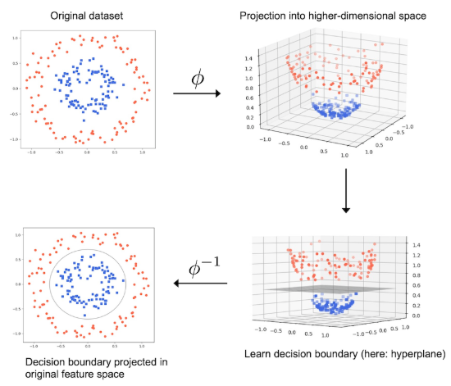

4 Experiments

4.1 Randomised Controlled Trial (RCT)
- Treatment Effect (TE) and Treatment Variable ($d$) which can be discrete or continuous.
AB trial is also known as a completely randomised design.
- A is the control group and B is the treatment group.
Average Treatment Effect (ATE) is:
- $ATE=E\left(y | d=1\right)-E\left(y | d=0\right)$, where $d$ must be independent of all other factors or $ATE=E\left[y\left(1\right)-y\left(0\right)\right]$.
Hence, we estimate:
- $\hat{ATE}={\overline{y}}_{1}-{\overline{y}}_{0}$ where $SE\left({\overline{y}}_{1}-{\overline{y}}_{0}\right)=\sqrt{Var\left({\overline{y}}_{1}\right)-Var\left({\overline{y}}_{0}\right)}$
Below is the demeaning-and-interacting way to get the ATE after a covariate adjustment:
- $E\left(y | d, cohort\right)=a_{cohort}+dγ_{cohort}$
- $E\left(y | d,x_{i}\right)=α\left|x_{i}+dγ\right|x_{i}$ (or $d\left|x_{i}\right)$
This is the equivalent to using subsamples to fit the regression separately.
- This uses interaction to capture heterogeneity better.
It is important to do a balance check to determine if there is a pattern in who retrieves treatment.

4.2 Difference-in-differences
Suppose the change is mixed where part of it is due to treatment and some other shock.
- If there is a comparable object that is not treated but also experiences the same other shock, then it can be differenced away.
The logic is as follows:
- Suppose object A has change $∆y_{A}=γ+α$, where $α$ is the other shock and $γ$ is the treatment effect.
- Let us say object B is not treated, but it is comparable to A and has $∆y_{B}=α$, then the difference of the differences is the treatment effect $γ=∆y_{A}-∆y_{B}$.
The difference-in-differences (DiD) model is as follows:
- $E\left(y_{it}\right)=α+β_{d}d_{i}+β_{t}t+γd_{i}t$
where,
- $β_{d}$ captures the treatment group’s property,
- $β_{t}$ captures the time effect or any other shocks during the treatment period,
- $γ$ is the treatment effect,
- $t$ takes value of 0 (before) and 1 (after),
- $d$ takes value of 0 (no treatment) and 1 treatment.
If we control for individual effects, we get as follows:
- $E\left(y_{it}\right)=α_{i}+β_{d}d_{i}+β_{t}t+γd_{i}t$
We have a subscript $i$ for individual effect $α_{i}$, instead of just $α$.
- This is related to random and fixed effects estimation of panel data models.

4.3 Regression Discontinuity Design (RDD)
The framework:
- A forcing variable (i.e., running variable) decides the treatment or not.
- There are no other confounders affecting the treatment allocation.
Notations:
- $y_{i}\left(d\right)$ potential outcomes for user $i$ under treatment $d$,
- $d_{i}$ is the treatment allocation for user $i$,
- $y_{i}\left(d_{i}\right)$ is the observed response (you cannot see the outcomes for all values of $d$ for $y_{i}$ in applications),
- $r_{i}$ is the forcing variable.
WLOG, assume the threshold of interest is always zero. You can always shift the variable by moving the threshold to $0$ if not. Hence,
- $d_{i}=1_{\left[r_{i}>0\right]}$
The assumptions are:
- $\left[y_{i}\left(0\right), y_{i}\left(1\right)\right]⊥d_{i}|r_{i}$, there are no confounders once $r_{i}$ is controlled for.
- Continuity, $E\left[y_{i}\left(d\right) | r=-ϵ\right]≈E\left[y_{i}\left(d\right) | r=0\right]≈E\left[y_{i}\left(d\right) | r=ϵ\right]$.
Figure 4.1: Regression Discontinuity Design (RDD)
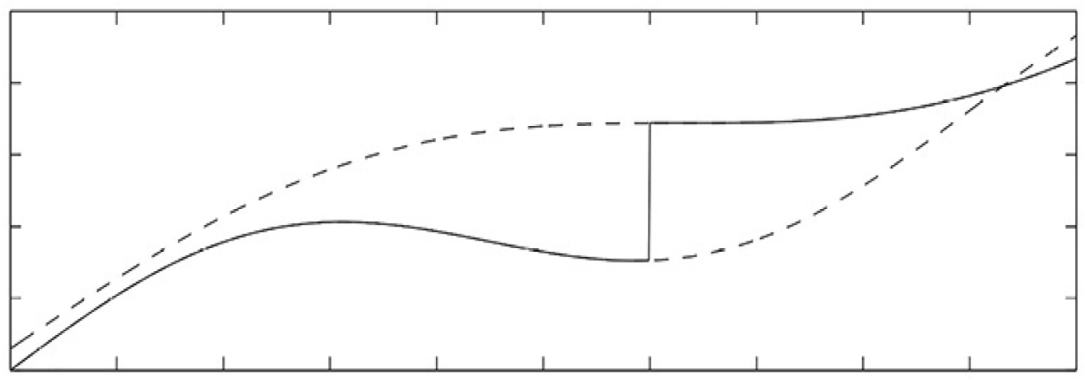
The simple model is as follows:
- On the left of $0$ when $r_{i}∈\left(-δ, 0\right)$, $E\left[y_{i}\right|r_{i}]=α_{0}+β_{0}r_{i}$.
- On the right of $0$ when $r_{i}∈\left(0, δ\right)$, $E\left[y_{i}\right|r_{i}]=α_{1}+β_{1}r_{i}$.
The first is when $d_{i}=0$ and the second is $d_{i}=1$. Then, the jump is:
- $E\left[y_{i}\left(1\right)-y_{i}\left(0\right) | r_{i}=0\right]=α_{1}-α_{0}$
RDD detects local treatment effect.
- This is a conditional ATE for $r_{i}≈0$. This is a limitation of RD.
Rank Score:
- A combination of bids and likelihood of being clicked.
- Ad with a higher score is shown first.
- $y$ is the revenue.
- $d$ is the treatment where $d=1$ means the ad is showing up in the mainline, above the main search results, and $d=0$ means on a sidebar.
- A reserved price exists. If the score is higher, then the ad shows on the mainline; otherwise on the sidebar.
- The rank score is normalised so the threshold is $0$.

4.4 LOWESS
LOWESS is a weighted least squares non-parametric method to explore local regression and sample statistics for curve fitting (it creates a smooth line).
- It can be thought of as related to moving average.
- The fitted value is easy to understand.
- It is used for making predictions when there exists a non-linear relationship between the features.
Figure 4.2: LOWESS
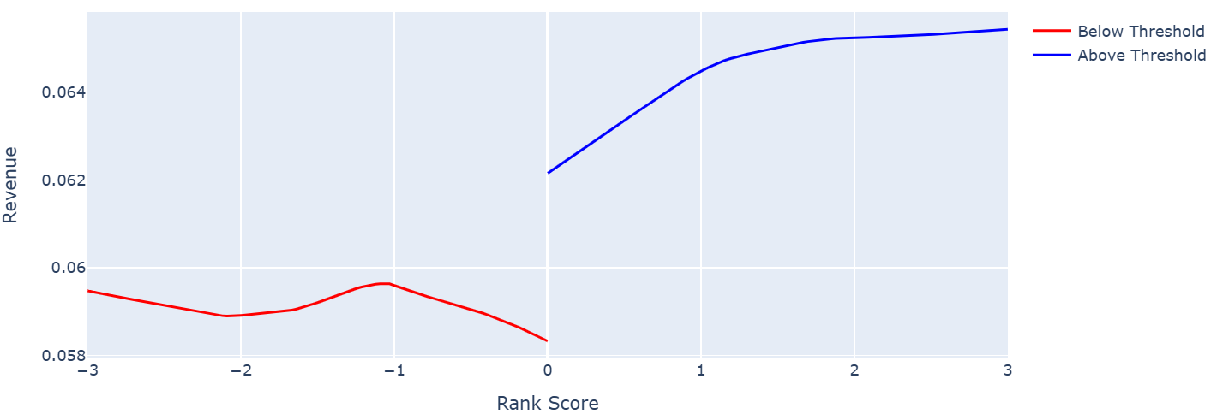

4.5 Local Linear Regression
The local linear regression is as follows:
- $E\left[y_{i}\right]=α+γd_{i}+r_{i}\left(β_{0}+β_{1}d_{i}\right)$
This is fit to localised subsets of the data.

4.6 Two-stage Least Squares (2SLS) and Instrumental Variables
Instrumental variables is when a third variable is introduced into the regression analysis that is correlated with the predictor variable, but uncorrelated with the response variable.
- $y=g\left(x,p\right)+e$, $cov\left(e, p\right)≠0$
We cannot disentangle the effect on $y$ from $p$ and $e$ (this is the key to economic analysis).
- ML focuses on prediction, such endogeneity is not important.
- Econometric analysis wishes to pin down the causality and infer potential policy effects or carry out counterfactual analysis.
A simple instrumental variable (IV) model is as follows:
- $y=β_{0}+β_{1}\hat{x}+ϵ$
- $\hat{x}+β_{0}+zγ+u$
where $z$ is the IV.
Figure 4.3: Two-stage Least Squares (2SLS) and Instrumental Variables
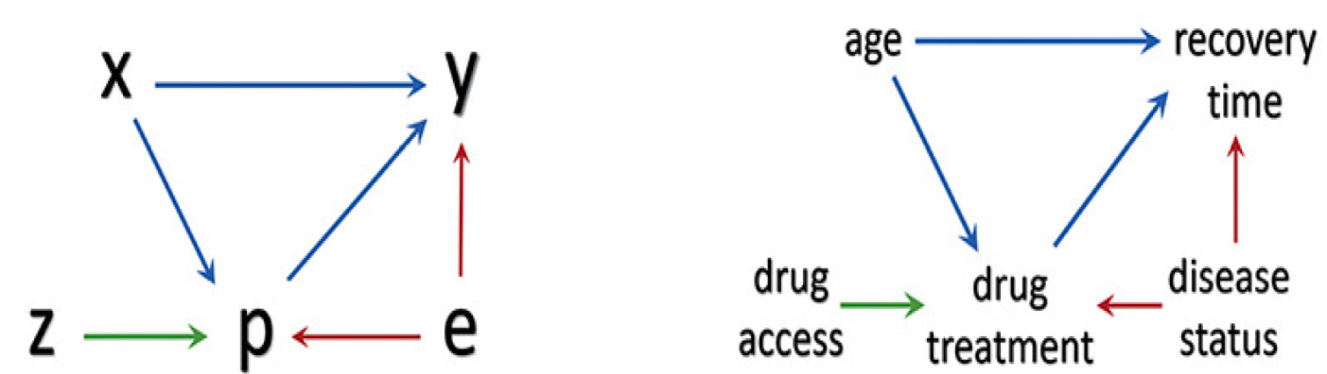

4.7 Matching
Matching is the process of pairing or weighting individuals in different groups (i.e., treatment and control groups) so they have similar characteristics, this helps make the groups comparable and isolates the effect of treatment. The assumptions of matching are:
- (1) unconfoundedness
- (2) overlap
Standardized Mean Difference (SMD) is a numeric measure of the difference between groups for a given variable.
- For continuous variables, it is calculated as the difference in group means divided by the pooled standard deviation.
- $0.1$ is the usual standard.
Score matching uses a regularised logistic model to predict pairs.
- Pairs have to overlap,
- Use score to match.

Figure 4.4: Normalised Variable Distribution
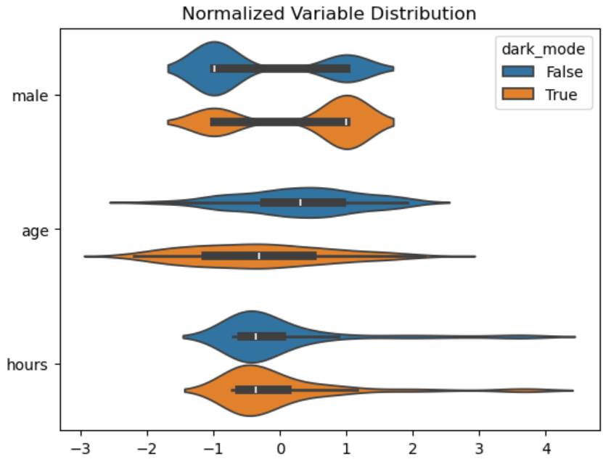
Figure 4.5: Normalised Variable Distribution after Matching
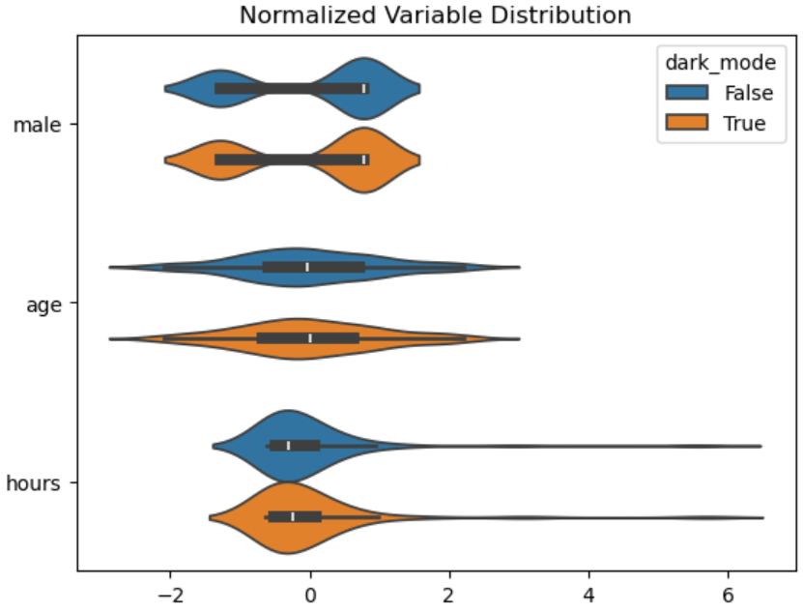
Figure 4.6: Balance Plot
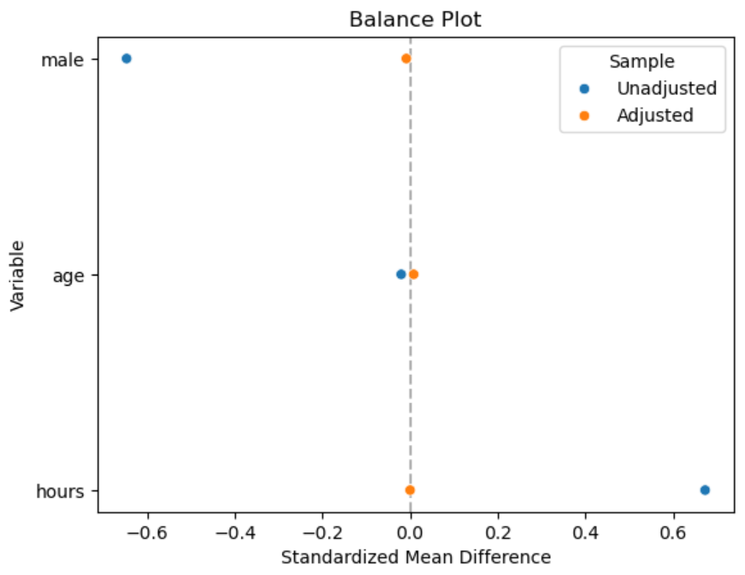

5 Controls

5.1 Linear Treatment Effects (LTE) Model
Conditional Ignorability (CI) means that we can have all variables that influence both treatment and response.
- $\left\{y_{i}\left(d\right) ∀ d\right\}⊥d_{i}|x_{i}$
For a simple linear regression model, this means:
- $y_{i}=x_{i}^{'}β+γd_{i}+ϵ_{i}$
CI implies $d_{i}$ is independent of $ϵ_{i}$.
- This is a typical exogeneity assumption.
The Frisch-Waugh-Lovell theorem states that by residualising $X_{1}$ from $X_{2}$, we purge out the control variables’ effect and the leftover residual is the exogenous shock.
- Traditionally, and for methodological consistency, you would also residualise the left-hand side when you residualise the right-hand side.
The Linear Treatment Effects (LTE) model is as follows:
- $y=dγ+x^{'}β+ϵ$, where $E\left[ϵ | d, x\right]=0$
and
- $d=x^{'}τ+v$, where $E\left[v | x\right]=0$
If you control a confounder, it may be added as an input.
- If the dimension becomes large, ML can then be used.

5.2 Heterogenous Treatment Effect
- $Y$ is the outcome,
- $T$ is the treatment,
- $X$ is the heterogeneity for the treatment effects (not necessarily the regressors),
- $W$ is the confounders (controls).
The DGP for heterogeneity and ATE can be represented in the regression form as:
- $y=α_{g}+γ_{g}d+ϵ$, where $ϵ \sim N\left(0, 1\right)$

Figure 5.1: Marginal Effects with Confidence Intervals
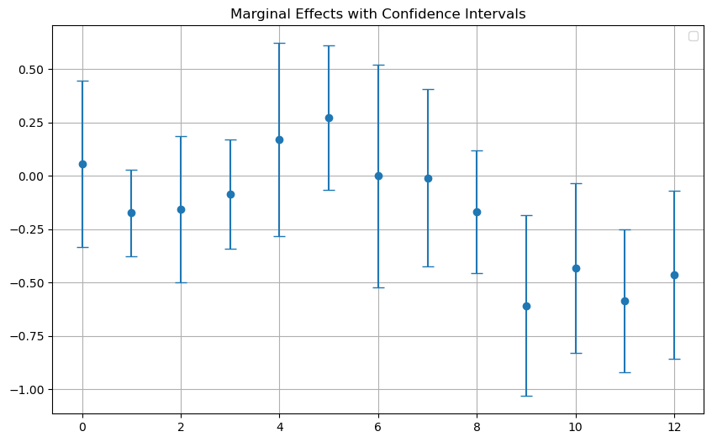

5.3 Double Machine Learning (DML)
Suppose we have the following:
- $Y=Dθ_{0}+g_{0}\left(X\right)+U$, where $E\left(U\right|X,D)=0$
- $D=m_{0}\left(X\right)+V$, where $E\left(V | X\right)=0$
It is not easy for $θ_{0}$ to be unbiased if $g_{0}$ is messy due to something such as large dimensionality.
- Any regularisation such as LASSO may bias the causal effect,
- But regularisation may be necessary if there are many covariates.
$V$ can be used as an IV.
- $V$ is related to $D$,
- $V$ is unrelated to $U$.
However, due to the nature of ML, the residual $\hat{V}$ would not be independent of $U$ easily. But, if we split the data as done in the cross validation, we get Double Machine Learning:
- Split the data.
- Use the training part to estimate $m_{0}$ and $g_{0}$.
- Get an OOS prediction of $\hat{V}$ with $D$ model.
- Use $\hat{V}$ with $Y$ model to obtain $\hat{θ}$ by using the test sample.
- You may average the $\hat{θ}$ from different folds, or aggregate the folds first to get an consolidated $\hat{θ}$. Latter is preferred.
In linking the DML paper to EconML, if we use the model:
- $Y=Dθ_{0}+g_{0}\left(X\right)+U$, where $E\left(U\right|X,D)=0$
- $D=m_{0}\left(X\right)+V$, where $E\left(V | X\right)=0$
We get CATE, the conditional Average Treatment Effect:
- $Y-E\left(Y | X\right)=\left[D-E\left(D | X\right)\right]θ_{0}+U$, where $g_{0}\left(X\right)$ is cancelled out.
This is why the following is necessary:
- Residual from model $Y$ for $Y-E\left(Y | X\right)$, and
- Residual from model $T$ for $D-E\left(D | X\right)$.
We need CV because we want to estimate the population $Y-E\left(Y | X\right)$ well.
- Any population is OOS, so CV is preferred.
The IV story from the DML paper is consistent with EconML if we disentangle the formula.
- They share the same idea of the 2SLS method and the FWL theorem.

5.4 Synthetic Controls
Synthetic controls aims to find similar observables to represent the control group.
- For instance, assume the time series data $y_{it}$, where $y_{it}\left(1\right)$ if treated and $y_{it}\left(0\right)$ otherwise, and we can only observe one of them.
Suppose the treatment happens at time $T$ for $i=1$.
- And only one series ($i=1$) is treated,
- you observe $y_{1t}=y_{1t}\left(0\right)$ for $t=1, 2, …,T$ and $y_{1, T+1}\left(1\right)$.
Suppose there are $J$ series including the treated one $i=1$, and all other $J-1$ series are not treated.
- We can only observe $y_{kt}\left(0\right)$ for $k=2, …,J$ and $t=1, …, T, T+1$.
The TE is:
- $y_{1,T+1}\left(1\right)-y_{1,T+1}\left(0\right)$
The matrix completion is as follows:
- $\left[\begin{matrix}y_{11}\left(0\right) & y_{12}\left(0\right) & ⋯ & y_{1t}\left(0\right) & ? \\ y_{21}\left(0\right) & y_{22}\left(0\right) & ⋯ & y_{2t}\left(0\right) & y_{2,T+1\left(0\right)} \\ ⋮ & ⋮ & ⋱ & ⋮ & ⋮ \\ y_{J1}\left(0\right) & y_{J2}\left(0\right) & ⋯ & y_{JT}\left(0\right) & y_{J, T+1}\left(0\right)\end{matrix}\right]$, use data from other series to predict series 1.
Algorithm 16:
- Build a model for $E\left[y_{1t}\left(0\right) | y_{-1t}\left(0\right)\right]$ and estimate by using data $t=1,…,T$.
- Use the model to predict unobserved $y_{1t}\left(0\right)$ for $t>T$. The treatment effect is: ${\hat{γ}}_{1,T+s}=y_{1,T+s}\left(1\right)-{\hat{y}}_{1,T+s}\left(0\right)$.
Figure 5.2: Application of Synthetic Control
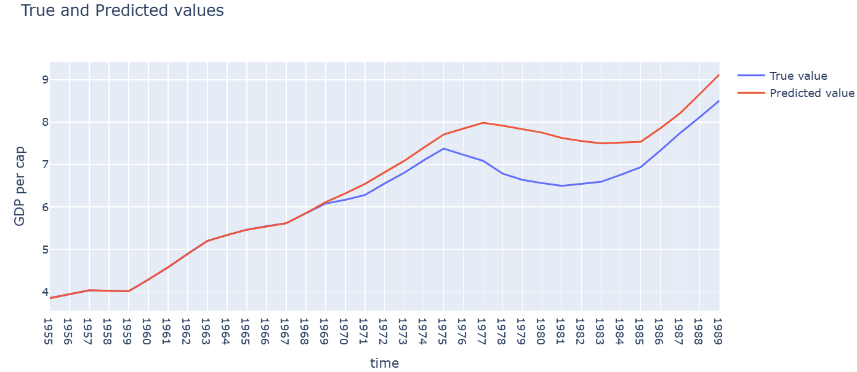

6 Factorisation

6.1 Clustering
Clustering is the grouping of data points based on shared characteristics. The mixture distribution is:
- $p\left(x\right)=π_{1}p_{1}\left(x\right)+…+π_{K}p_{K}\left(x\right)$
where,
- $π_{i}$ is the probability (weight) of being in group $i$,
- $p_{i}()$ is the probability law in group $i$.
The $k$-mean normal mixture (a generalised multivariate model):
- $p_{k}\left(x\right)=N\left(x\right|μ_{k}, Σ_{k})$
where,
- $N()$ is the multivariate normal distribution,
- $Σ_{k}$ is the covariance matrix in group $k$.
If each element of $x$ is independent of the others,
- then covariance has a diagonal structure as $Σ_{k}=σ_{k}^{2}I_{N}$.
The $k$-means method (Algorithm 17) does not care about the underlying distribution. Suppose the data is ${\left\{x_{i}\right\}}_{i=1}^{n}$.
- Initialisation. Membership $k_{i}$.
- Estimate the means ${\hat{u}}_{k}=\frac{1}{n_{k}}\sum_{i:k_{i}=k}{x_{i}}$, where $n_{k}$ is the number of observations in group $k$.
- Update the membership $k_{i}$, $k_{i}=\arg{\min_{k}{\sum_{j}{{\left(x_{ij}-{\hat{u}}_{kj}\right)}^{2}}}}$.
We simply find the closest component (scaling is important here).
- Overall, we minimise the distance function by first beginning with $k$ points and then we keep selecting centroids until the average distance is minimised.
$t$-SNE or $t$-distributed stochastic neighbour embedding where we visualise high-dimensional datasets in two or three dimensions.

Figure 6.1: Two-dimensional visualisation of a data set
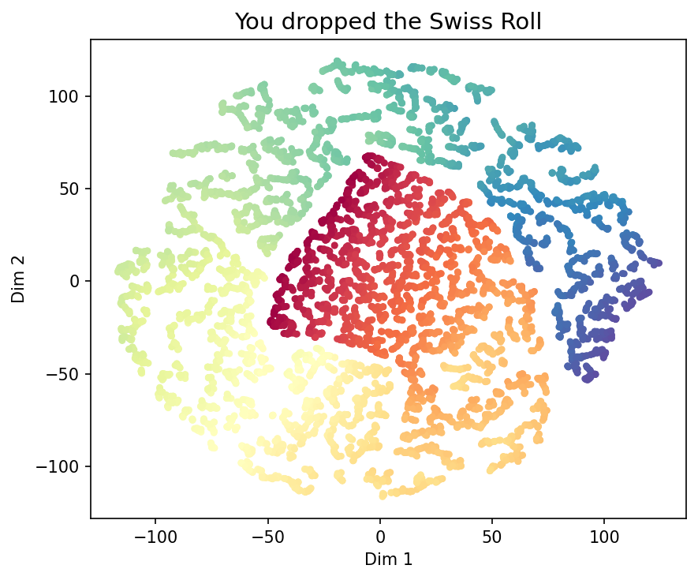
Figure 6.2: Three-dimensional visualisation of a data set
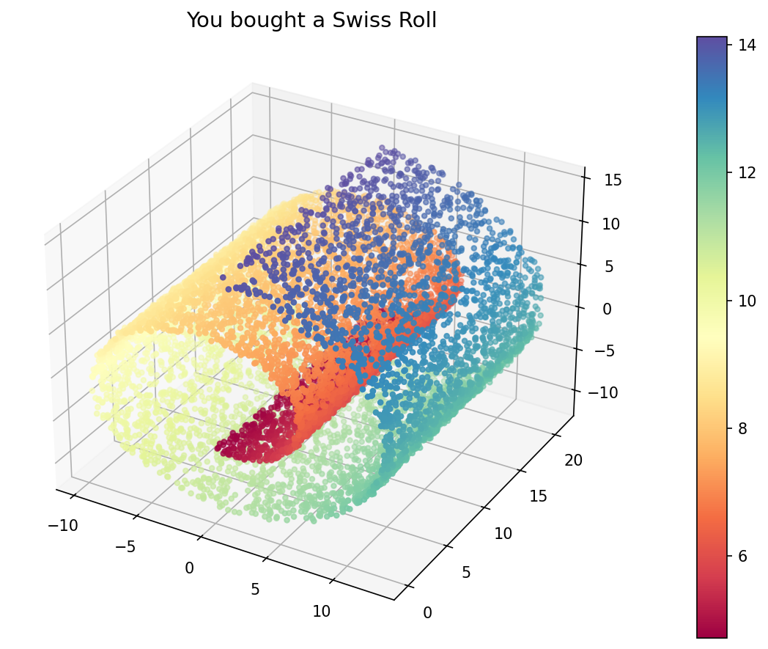

Figure 6.3: $t$-SNE of Protein Consumption Data
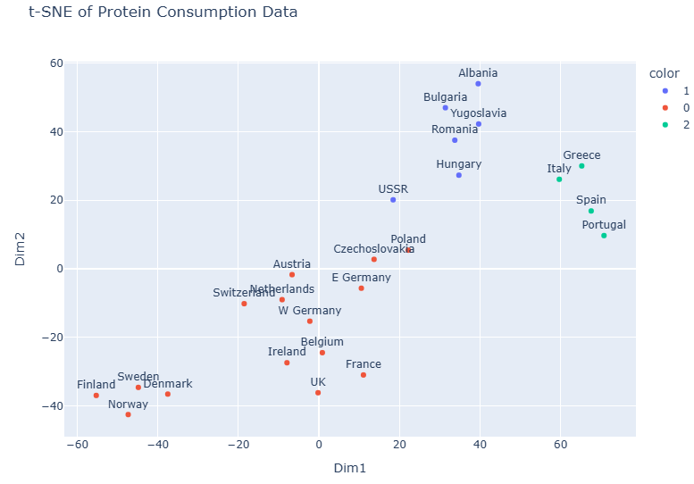
There are also alternative methods such as Leave-One-Out-Cross-Validation (LOOCV) and the Elbow Method.
- In LOOCV, a single data point is removed from the dataset, and the model is trained on the remaining data points.
- The removed data point is then used as a test case to evaluate the model’s performance.
- This process is repeated for each data point in the dataset, allowing each observation to be used exactly once as a test instance.
- The Elbow Method is a technique for selecting the number of clusters in $k$-means by plotting the mean squared error (MSE) versus the number of clusters and choosing the point where improvements start to level off (the elbow).
Figure 6.4: Elbow Method for Optimal $k$ (Leave-One-Out CV)
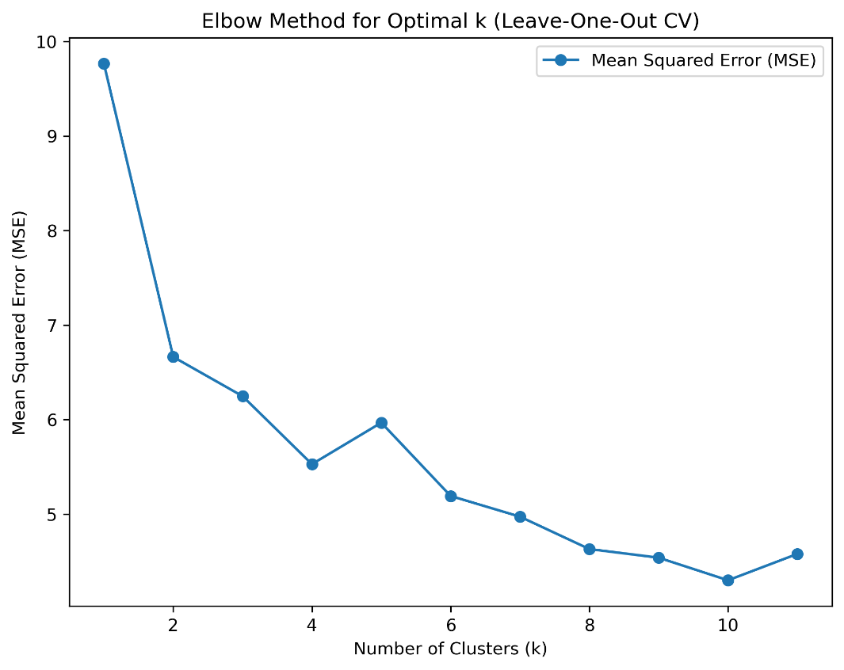

6.2 Principal Component Analysis (PCA)
Principal component analysis is a dimensionality reduction technique that transforms a daset into a set of orthogonal components, known as principal components, which are new uncorrelated variables formed as linear combinations of the origin features that capture the maximum variance in the data.
- $E\left[x_{i}\right]=ϕ_{1}v_{i1}+…+ϕ_{k}v_{iK}$ (1)
where,
- $x_{i}$ and $ϕ_{k}$ ($k=1, …,K$) are length-$p$ vectors,
- $v_{ik}$ ($k=1,…,K$) are scalars.
If $K≪p$, the model is parsimonious. (1) expands to (2):
- $E\left[x_{ij}\right]=ϕ_{j1}v_{i1}+…+ϕ_{jK}v_{iK}$
for $j=1,…,p$.
- $v_{ik}$ are the property of $x_{i}$ (they are indexed by $i$),
- $ϕ_{jk}$ are coefficients (they apply to other $x$),
- $ϕ$ is the slope (and a component representing some sort of pattern),
- $v$ are the coordinates of all $x$ on the line.
Figure 6.1: Principal Components
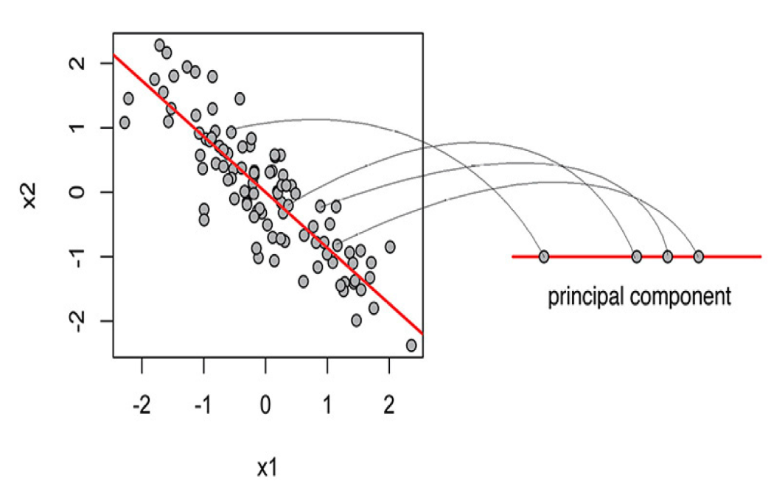
Figure 6.2: PC1 and PC2
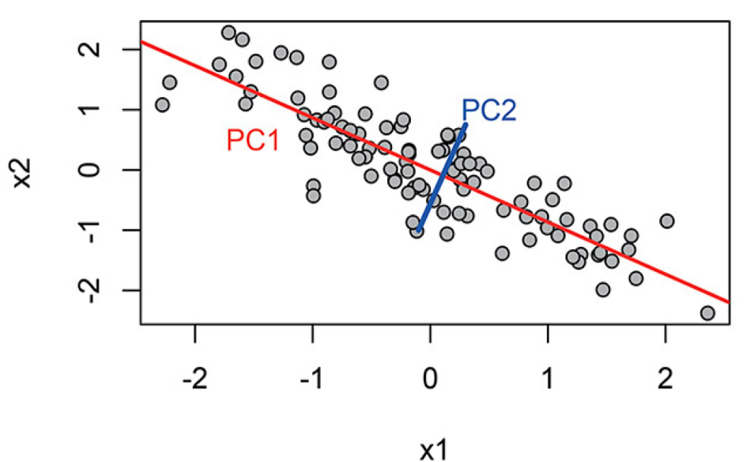
For two-dimensional data, two PCs are enough. Algorithm 18 (PCA) is as follows:
- Set ${\tilde{X}}^{1}=X$, which is $n×p$ (think design matrix). For $k=1, …,\min\left(n,p\right)$,
Find,
- $ϕ_{k}=\arg{\max_{ϕ_{k}}{[var\left({\tilde{X}}^{k}ϕ_{k}\right)=var\left\{v_{k1},…,v_{kn}\right\}}]}$,
where $v_{ki}=ϕ_{k}^{'}x_{i}$ and $\sum_{j=1}^{p}{ϕ_{kj}^{2}=1}$.
- Update rows of ${\tilde{X}}^{k}$ via ${\tilde{x}}_{i}^{k+1}={\tilde{x}}_{i}^{k}-v_{ki}ϕ_{k}$.
In the context of PCA, the subscripts mean:
- $k$ means components with $k=1,…,K$
- $i$ means observation with $i=1,…,n$
- $j$ indicates variable (elements in $x$) with $j=1,…,p$
Figure 6.3: Cumulative and individual explained variance
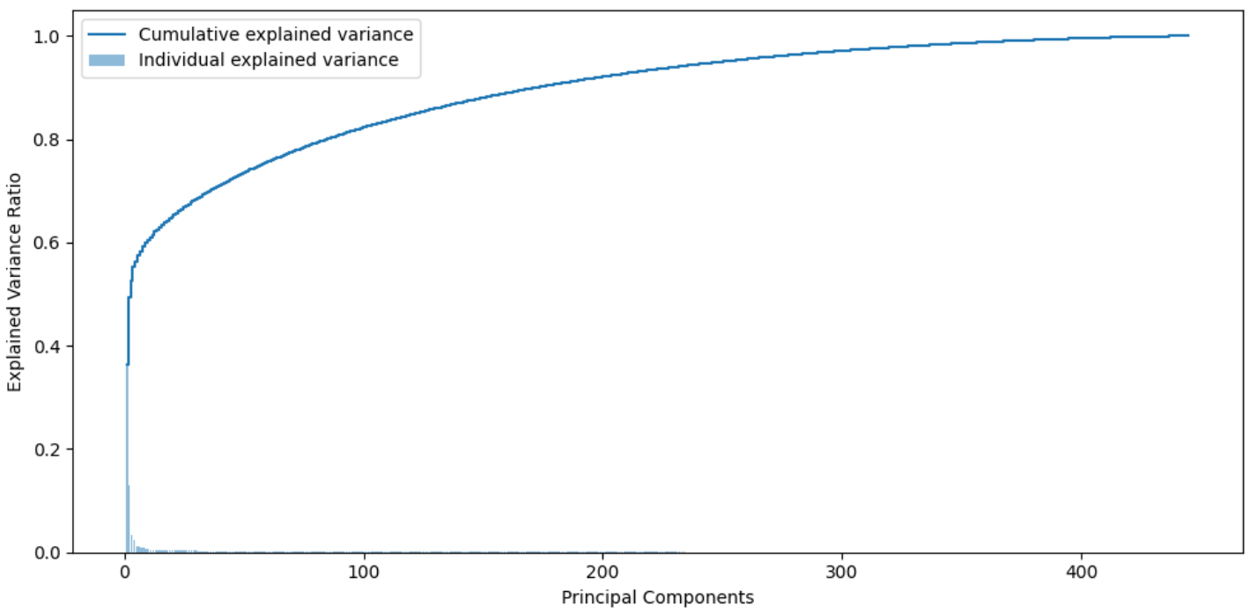
Figure 6.4: Principal components and cumulative and individual explained variance
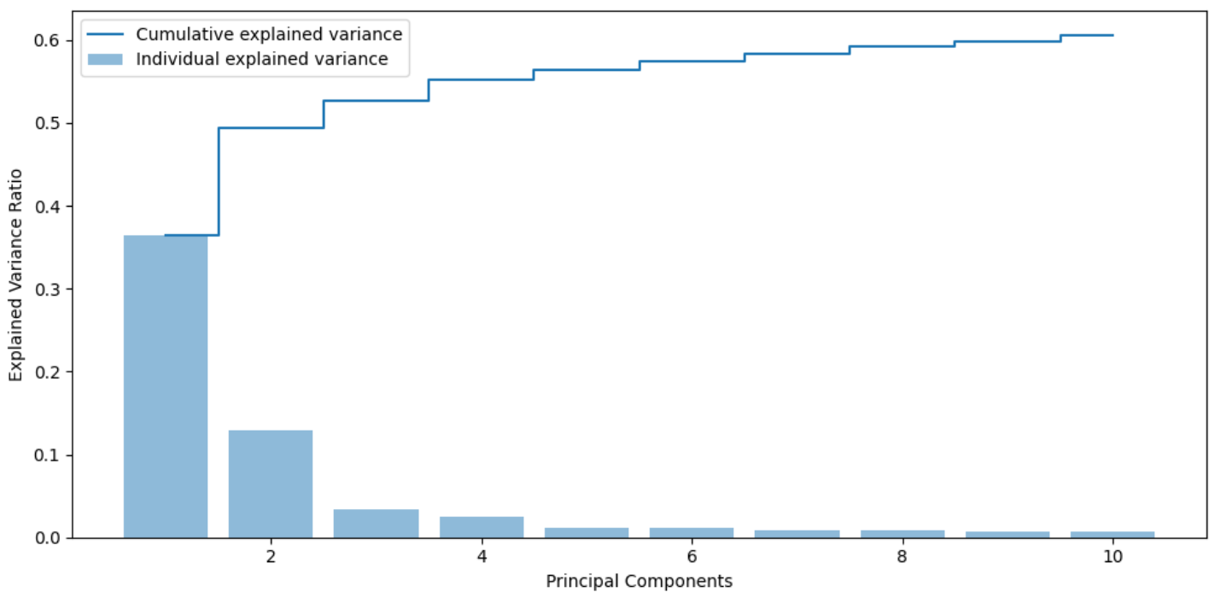

In interpreting the coefficients, the sign does not matter in a PC rather the magnitude is what is important.
- For a top-down interpretation, check the values of $v_{ik}$,
- For a bottom-up approach, check the values of $ϕ_{k}$.
Algorithm 19 Principal Component (LASSO) Regression is when instead of regressing $y$ on $x$’s PCs, we try lasso on both PCs and $x$. Hence, the procedure is as follows:
- Fit PCA on the full set of $x_{i}$ inputs to obtain $v_{i}$ of length $\min\left(n, p\right)$ where $n$ is the sample size and $p$ is the dimension of $x_{i}$.
- Run LASSO regression for $y_{i}$ on $v_{i}$ for various subsets.
- Or, regress $y$ on all $x$ and $v$ simultaneously via LASSO.

6.3 Marginal Regression
Marginal regression involves regressing the outcome variable on each principal component separately to assess how strongly each component is associated with the outcome. Algorithm 20 Marginal Regression:
- Calculate OLS coefficient $ϕ_{j}$ for simple univariate regression of $y$ on $x_{j}$ for $j=1,…,p$
- Set $v_{i}=x_{i}^{'}ϕ$ for each observation $i$.
- Fit the forward univariate linear regression $y_{i}=α+βv_{i}+ϵ_{i}$.
The variable $v_{i}$ works as an index.

6.4 Partial Least Squares
PLS is repeated MR on its previously obtained residual. Algorithm 21:
- Start MR for $y$ on $x$. Denote the factor as $v^{1}$ and the fitted value ${\hat{y}}^{1}$.
- For the $k$th iteration, get residuals (from the $k-1$th step) ${\tilde{y}}_{i}^{k-1}=y_{i}-{\hat{y}}_{i}^{k-1}$.
- Repeat MR but use ${\tilde{y}}_{i}^{k-1}$ as the dependent variable.
- Get new fitted value ${\hat{y}}_{i}^{k}={\hat{y}}_{i}^{k-1}+β_{k}v_{i}^{k}$.
This idea is called boosting.
- PLS is boosted MR.
Figure 6.5: PLS(1) vs. MR
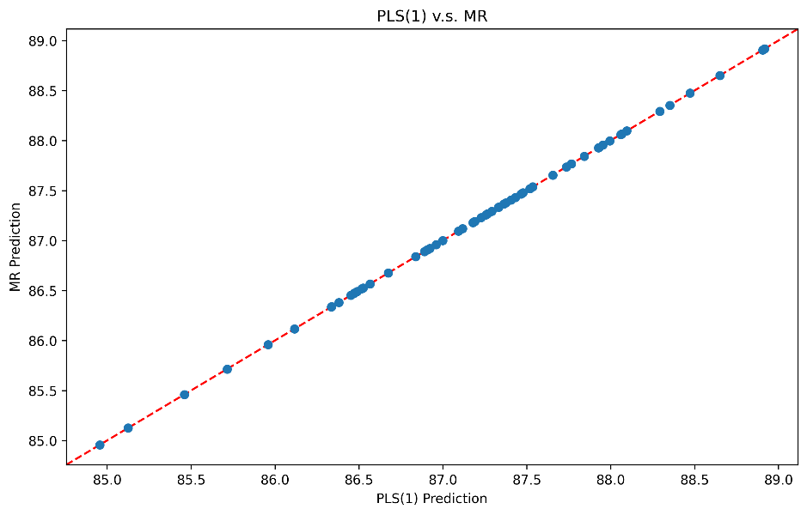
Figure 6.6: PLS(1), (2) and (3)
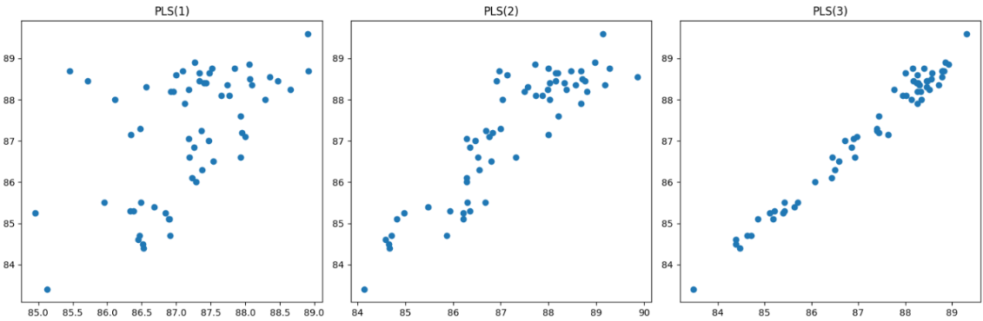
Figure 6.7: Root Mean Squared Error of Cross-Validation vs. Number of Components
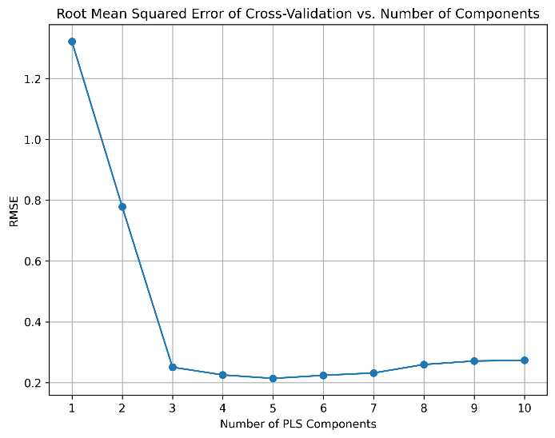

6.5 Linear Discriminant Analysis (LDA)
Similar to PCA but it is supervised and used for classification.
- LDA tries to choose $k$ components to maximise the between-class variations among $X$ variables, since we can observe these classes.
- PCA instead tries to choose $k$ components to maximise variations among $X$ variables, since it ignores the observables.
- LDA and PCA both use linear transformation.
Figure 6.8: Linear Discriminant Analysis
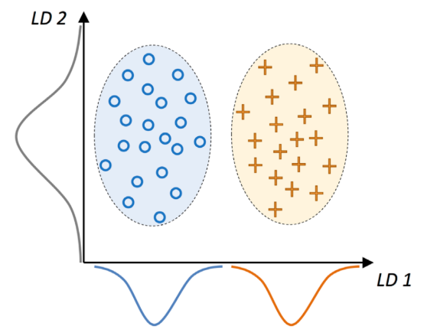
- The $y$-axis provides more variation, and why it is preferred by PCA.
- However, $x$-axis separates two classes, which is why we want supervision.
Figure 6.9: Linear Discriminant Analysis on Wine Data
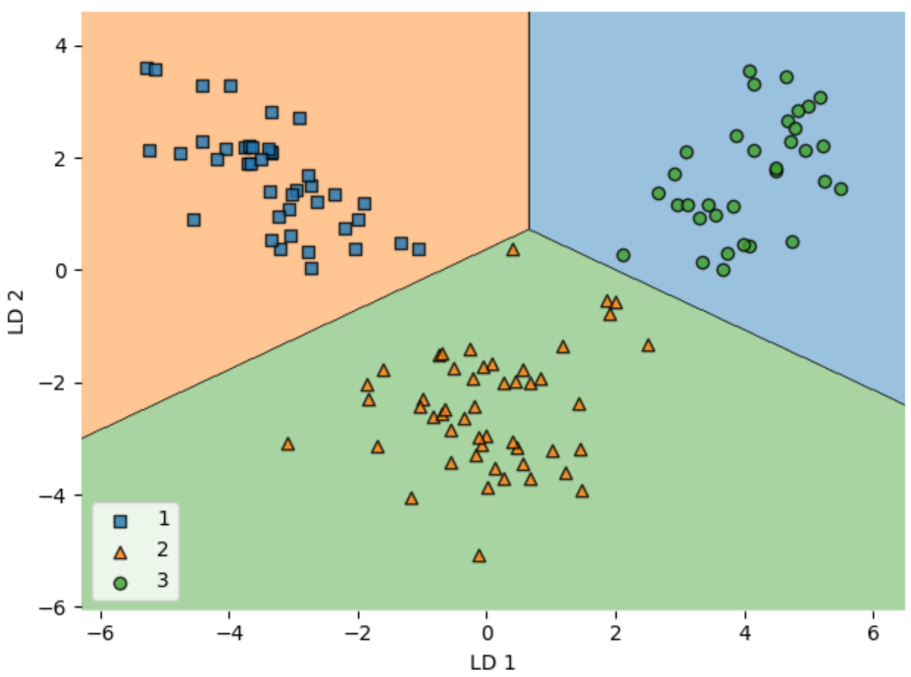

7 Nonparametrics

7.1 Decision Tree
Trees are hierarchical involving a series of steps to the conclusion.
- The fundamental unit of the tree data structure is called a node.
The final decision is the leaf node.
- Each node except the root has a parent,
- Each node except the leaves has two children.
Figure 7.1: Decision Tree for an Umbrella
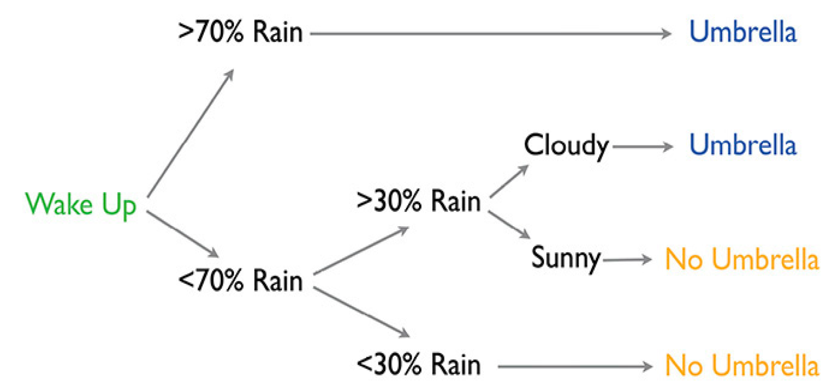
Figure 7.2: Decision Tree
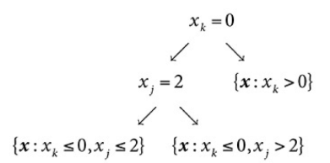
To predict, compute the sample average (or proportion) in the leaf depending on the loss function (most results are intuitive). A split of a node with data ${\left\{x_{i},y_{i}\right\}}_{i=1}^{n}$ (this could be a subset after several splits) has the following characteristics:
- $x_{i}$ is a vector split on an element $x_{ij}$,
- splitting the $j$th element produces two children:
- left: $\left\{x_{k}, y_{k}:x_{kj}≤x_{ij}\right\}$
- right: $\left\{x_{k}, y_{k}:x_{kj}>x_{ij}\right\}$
- Loss function is: $\sum_{k ∈ left}{{\left(y_{k}-{\overline{y}}_{left}\right)}^{2}}+\sum_{k ∈ right}{{\left(y_{k}-{\overline{y}}_{right}\right)}^{2}}$

This method is called classification and regression tree (CART). CART Algorithm 23 is as follows:
- We first begin with the root containing the full sample, then:
- Find location $x_{ij}$ that minimises the loss function: $\sum_{k ∈ left}{{\left(y_{k}-{\overline{y}}_{left}\right)}^{2}}+\sum_{k ∈ right}{{\left(y_{k}-{\overline{y}}_{right}\right)}^{2}}$,
- Split accordingly,
- Repeat these steps for each child.
This procedure is repeated until a leaf node reaches a minimum size.

7.2 Pruning
A tree most be grown first in order for the penalty term to be understood. This step is application dependent.
- Start from closest to leaves (most unimportant),
- End with the root,
- Each ccp_alpha is the cut-off value such that we are indifferent between pruning or not,
- $R_{α}\left(T\right)=R\left(T\right)+αT$, where $α$ works as the penalty term.
Figure 7.3: Total Impurity of Leaves
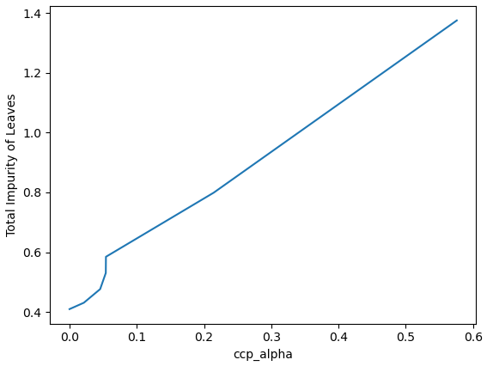
Figure 7.4: Tree Size vs. OOS Loss
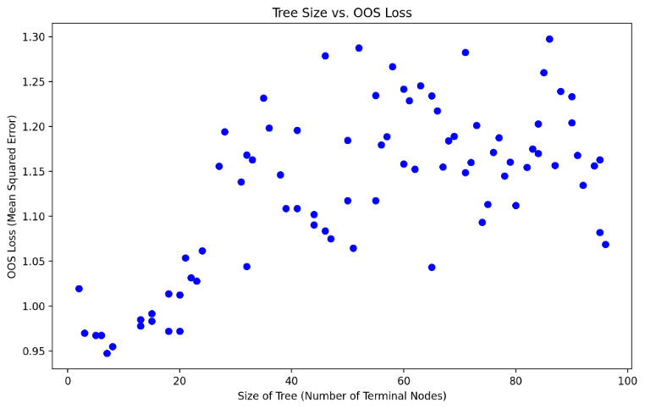
Shapley Additive exPlanations (SHAP) values are a way to explain the output of any machine learning model.
- It uses a game theoretic approach that measures each player’s contribution to the final outcome.
- In machine learning, each feature is assigned an importance value representing its contribution to the model’s output.
- Features with positive SHAP values positively impact the prediction, while those with negative values have a negative impact.
- The magnitude is a measure of how strong the effect is.
SHAP values show how each feature affects each final prediction, the significance of each feature compared to others, and the model’s reliance on the interaction between features.
Figure 7.5: SHAP Values
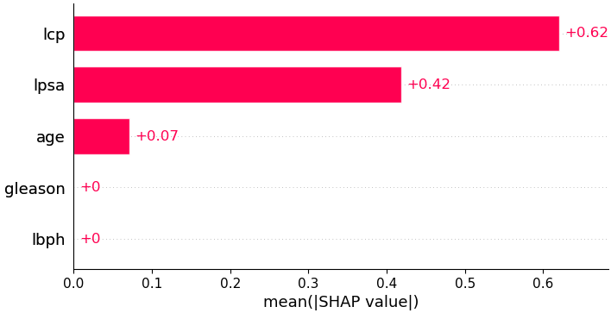
Figure 7.6: SHAP Value at a Particular Observation
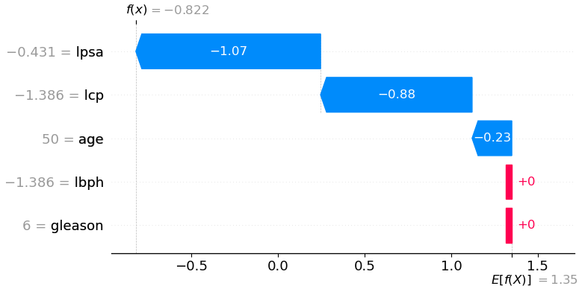

7.3 Random Forest (RF)
Random forest combines the predictions of multiple decision trees to procedure a more accurate and robust result.
- A tree can be unstable. A subtle difference in the node could lead to a significant deviation in the prediction for different trees.
- Bagging: bootstrap aggregating. It takes care of uncertainty to stabilise the model and hence prediction. It can be interpreted as Bayesian model averaging (BMA).
- RF may damage performance when $n$ is large.
- RF is an ensemble method, meaning it aggregates outputs of several models (decision trees) to improve performance.
Algorithm 24 $B$ is the bootstrap size.
- Sample with replacement $n$ observations from the data,
- Fit a CART tree $T_{b}$ to the sample.
For $b=1,…,B$, there are $B$ trees $T_{1},…,T_{B}$. The prediction is simply the sample average of predictions from all trees.
Figure 7.7: Feature Importances and Relative Importance
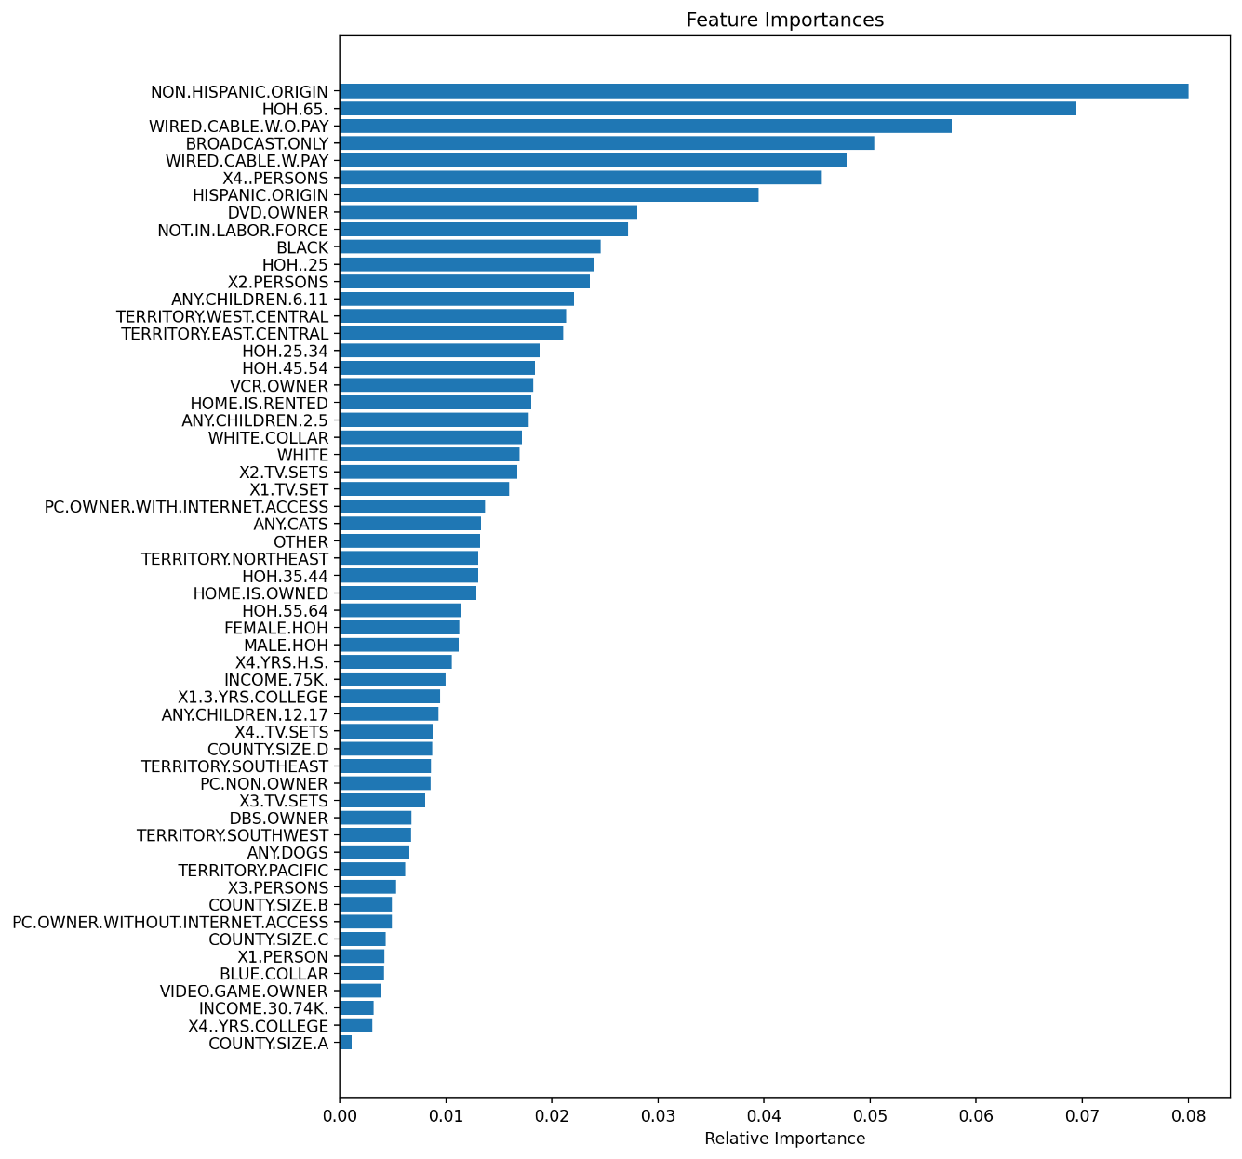

7.4 ADABoost
ADABoost is a sequence of stumps that being used as a stump forest. The algorithm is as follows:
- Initialisation, each observation has equal weight as $w_{i}=1/n$.
- Train a weak learner $t$ (a stump: one root with only two leaves).
- Find error $ϵ_{t}=\sum_{i=1}^{n}{w_{i}1}$ (wrong classification). Obviously, $ϵ∈\left(0, 1\right)$, we give a little margin if it is exactly equal to 0 or 1.
- Find the weight of this weak learner $α_{t}=\frac{1}{2}\ln\left(\frac{1-ϵ_{t}}{ϵ_{t}}\right)$. Small error had large weight, this is intuitive.
- Now reweight the observations/data, so that the misclassified observations receive more weight and be taken care of for the next round. This is the idea of boosting, $w_{i}←w_{i}\exp\left(α_{i}\right)$ if $i$ is misclassified; and $w_{i}←w_{i}\exp\left(-α_{t}\right)$ if $i$ is correctly classified.
- You must normalise the weight to sum up to 1 (normalisation).
- Repeat until many stumps are generated sequentially.
- Because of various re-weighting, some stumps are good at certain observations while others are good at something else.
- Collect all weak learners and form decision in parallel.
- Every stump has a vote, but each has its weight $α_{t}$,
- Add up all the weighted vote for category 1,
- Add up all the weighted vote for category 0,
- Make decision based on votes.

7.5 Gradient Boosting
Gradient boosting combines multiple weak predictions models into a single ensemble. It attempts to understand the difficult-to-model relationships between features. The algorithm is as follows:
- Start (initialisation) from a weak learner $F_{0}\left(x\right)$. For example, $F_{0}\left(x\right)=\arg{\min_{c}{\sum_{i=1}^{n}{L\left(y_{i}, c\right)}}}$. It can be so weak that you do not even need $x$ variable in this example (e.g., sample mean),
- Improve using the Taylor rule: $F\left(x\right)=F\left(x_{0}\right)+∇F\left(\tilde{x}\right)\left(x-x_{0}\right)$,
- Let us find the gradient (partial derivative), $r_{i}^{\left(m\right)}=-{\left(\frac{∂L\left(y_{i}, F\left(x_{i}\right)\right)}{∂F\left(x_{i}\right)}\right)}_{F=F_{m-1}}$ where $m$ is the $m$th iteration,
- The residual is clearly not the Taylor expansion, however, do not need to go deep for the model parameters,
- we only need to look at the loss function superficially,
- the whole part $∇F\left(\tilde{x}\right)\left(x-x_{0}\right)$ is learned together.
- Train another weak learner $h_{m}\left(x\right)$ to fit the residual $r_{i}^{\left(m\right)}$,
- this $h_{m}\left(x\right)$ approximate the partial derivative,
- heuristically, each $x$ (or future $x$) would indicates a direction to improve the loss function via $h_{m}\left(x\right)$, approximately,
- $h$ is usually a tree.
- For robustness, we need a learning rate to update the new function, $F_{m}\left(x\right)=F_{m-1}\left(x\right)+ηh_{m}\left(x\right)$,
- Repeat many times until satisfied (some stopping rules should apply).

7.6 LightGBM
LightGBM is a gradient boosting method which constructs a strong learner by sequentially adding weak learners in a gradient descent manner. This is from Microsoft, which has a similar idea as gradient boosting.
- Faster training speeds and higher efficiency,
- Lower memory usage,
- Better accuracy,
- Support of parallel, distributed, and GPU learning,
- Capable of handling large-scale data.

7.7 XGBoost (Extreme Gradient Boosting)
XGboost is a gradient boosting method which builds models sequentially, with each new tree correcting the errors of the previous ones and includes regularisation to prevent overfitting. This is the same idea as gradient boosting but with a new way to grow the tree to learn the gradient.
- This explicitly accounts for Hessian (which is why XGBoost is strong),
- This involves regularisations (Bayesian again).
Key parameters:
- $λ$ regularise/reduce similarity score for (1) robustness (reduce sensitivity) and (2) discouraging over splitting.
- $γ$ threshold compared to splitting gain. If the gain is larger than $γ$, then split. It discourages over splitting, as well.
- $η$ learning rate.
The accuracy is:
- $\frac{number of correct predictions}{number of total predictions}$
Figure 7.8: LightGBM Validation Set
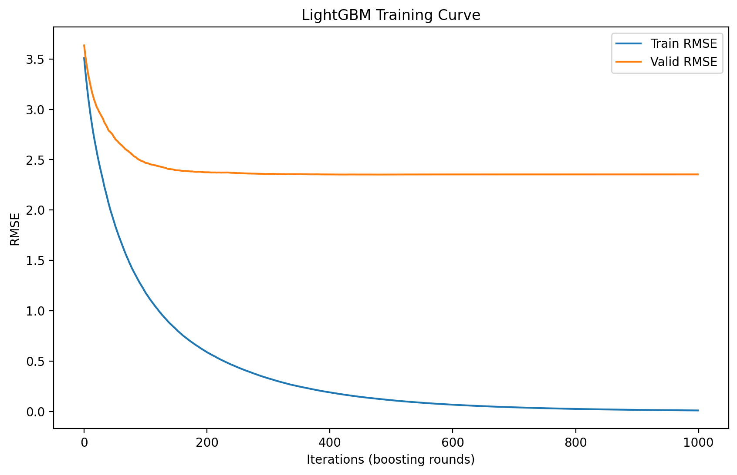

Figure 7.9: XGBoost Validation Set
